LITERARY PUB QUIZ

PICTURE ROUND:

NAME THESE FAMOUS WRITERS

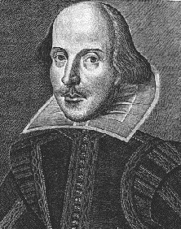 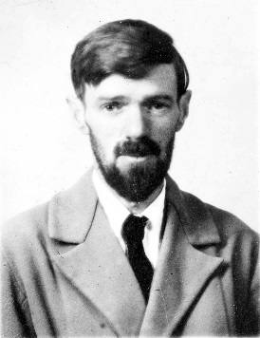 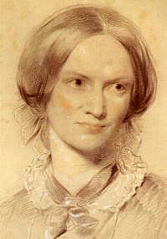

1. 2. 3.

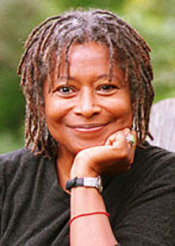 [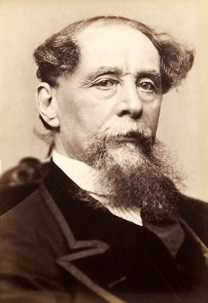](https://www.google.co.uk/url?sa=i&rct=j&q=&esrc=s&frm=1&source=images&cd=&cad=rja&uact=8&ved=0CAcQjRxqFQoTCPHhtsi47scCFcfbGgod4sQOvg&url=https://en.wikipedia.org/wiki/Charles_Dickens&psig=AFQjCNGqwfI9h2MVJI4PhitxE3f9DSGCHw&ust=1442042357695079) [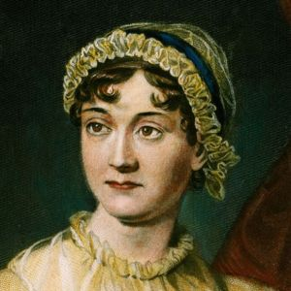](http://www.google.co.uk/url?sa=i&rct=j&q=&esrc=s&frm=1&source=images&cd=&cad=rja&uact=8&ved=0CAcQjRxqFQoTCIehpJS57scCFUW9GgodkyoI6Q&url=http://www.pandptours.co.uk/jane-austen/&psig=AFQjCNE_iZq-Hj1bGrnwx_xBvsodVstPmA&ust=1442042427273687)  
4. 5. 6.

[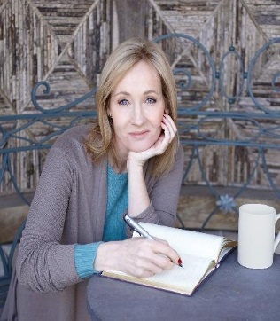](http://www.google.co.uk/url?sa=i&source=imgres&cd=&cad=rja&uact=8&ved=0CAkQjRwwAGoVChMI9bfJqrnuxwIVZLPbCh3RZQf3&url=https://twitter.com/jk_rowling&psig=AFQjCNFpbypAnlfd_vNZVhJ2XbVolH14JA&ust=1442042570576677)

7.

1. Who wrote ‘Wuthering Heights’?

Jane Austen? Emily Bronte? Charles Dickens?

1. In which novel by Charles Dickens does the character Miss Havisham appear?

Oliver? Great Expectations? Bleak House?

1. What is the real name of the novelist George Eliot?

Marian Evans Lewes? Mary Jane Smith? Marie Louise Pritt?

1. What was the pseudonym of Charlotte Bronte?

Charlotte Brown? Currer Bell? Caroline Burrows?

1. In which fictional county are Thomas Hardy’s novels set?

Brightonshire? Wessex? Rutlandshire?

1. What do the poet W.H. Auden’s initials stand for?

Wystan Hugh? William Henry? Walter Hendrik?

1. Who are the pair of ‘star cross’d lovers’ in literature?

Tristan and Isolde? Romeo and Juliet? Mork and Mindy?

1. How many lines does a sonnet contain?

18? 16? 14?

1. Which American poet was married to Ted Hughes?

Sylvia Plath? Toni Morrison? Maya Angelou?

1. From which novel does the concept of Room 101 originate?

Harry Potter and the Goblet of Fire? 1984? Animal Farm?

1. Complete the line from Shakespeare’s sonnet, “Shall I compare thee …”

To the moon? To a summer’s day? To the golden sun?

1. Who wrote the poem, ‘The Tyger’?

William Blake? Mark Twain? Jane Austen?

1. What is the name of the hero in Jane Austen’s novel, ‘Pride and Prejudice’?

Mr. Collins? Mr. Bennett? Mr. Darcy?

1. What are ‘not the only fruit’ for Jeanette Winterson?

Lemons? Oranges? Pears?

1. Who wrote the novel ‘Of Mice and Men’?

John Steinbeck? Rudyard Kipling? Ernest Hemingway?

1. Who is the current poet laureate?

Andrew Motion? Carol Ann Duffy? Simon Armitage?

1. Who wrote ‘The Lord of the Rings’ trilogy?

Tolkein? Dickens? Auden?

1. Who wrote ‘The Jungle Book’?

Rudyard Kipling? J.K. Rowling? Dan Brown?